A.V.KAVERI,
192512188.
Experiment No:5
Simulation of a Smart Hospital Live Patient Monitoring System Using Python (Google Colab)

Aim
To develop and simulate a Smart Hospital Live Patient Monitoring System using Python in Google Colab , In a smart hospital ward, IoT sensors continuously measure patient vital signs such as temperature, heart rate, and SpO₂. These readings are processed in real time using Python in Google Colab, displayed through live tables and graphs, and compared against medical thresholds. If abnormal values are detected, the system automatically classifies the patient as an emergency case and raises instant alerts, ensuring timely medical intervention.

Objective
The objective of this experiment is to simulate a smart hospital patient monitoring system using Python in Google Colab. The system continuously monitors the vital signs of 25 patients by generating simulated values for body temperature, heart rate, and blood oxygen saturation (SpO₂) at regular intervals of five seconds. The monitored data are displayed in a live dashboard containing continuously updating tables and graphical visualizations for real-time observation. The system analyses each patient's health condition by comparing the generated values with predefined threshold limits and classifies them as either NORMAL or EMERGENCY. Whenever abnormal vital signs are detected, the system immediately displays an emergency alert along with the patient's details. This experiment demonstrates how live patient monitoring, automated health status classification, emergency detection, and real-time visualization can be implemented through simulation using Python in Google Colab.

Software Requirements
Google Colab
Python 3.x
Python Libraries Used
pandas
numpy
matplotlib
IPython.display
random
time

Theory
A Smart Hospital Monitoring System continuously observes the health condition of patients by collecting their vital signs such as body temperature, heart rate, and oxygen saturation. In real hospitals, these values are obtained using medical sensors connected through IoT or IoE devices. Since physical hardware is not used in this experiment, the patient data are simulated using randomly generated values that resemble real medical readings.

The system processes one patient every five seconds and updates the monitoring dashboard dynamically. After every update, the patient's vital signs are analysed against predefined threshold values. If any vital sign falls outside the normal range, the patient is classified as EMERGENCY; otherwise, the patient is considered NORMAL.

The generated information is displayed in a live table and continuously updated graphs, allowing healthcare staff to monitor patient conditions effectively. This simulation demonstrates the working principle of a real-time patient monitoring system without requiring physical medical devices.

Algorithm
Start the program.
Import all required Python libraries.
Set the total number of patients to 25.
Set the monitoring interval to 5 seconds.
Create empty lists to store patient information.
Generate random Temperature, Heart Rate, and SpO₂ values.
Compare each patient's values with predefined threshold limits.
Assign the patient status as NORMAL or EMERGENCY.
Store the generated data.
Display the live patient monitoring table.
Display emergency patients separately.
Update the live graphs.
Wait for five seconds.
Repeat until all 25 patients are monitored.
Display "Monitoring Completed Successfully".
Stop the program.

Flowchart
START
│
▼
Import Required Libraries
│
▼
Initialize Monitoring System
│
▼
Set Total Patients = 25
│
▼
Generate Patient Data
│
▼
Temperature, Heart Rate, SpO₂
│
▼
Compare with Threshold Values
│
┌───────────┴───────────┐
│ │
▼ ▼
NORMAL EMERGENCY
│ │
└───────────┬───────────┘
▼
Store Patient Information
│
▼
Display Live Monitoring Table
│
▼
Update Live Graphs
│
▼
Wait 5 Seconds for Next Patient
│
▼
More Patients Remaining?
│ │
Yes No
│ │
▼ ▼
Generate Next Display Final
Patient Data Summary
│
└──────────────►
▼
END
Threshold Values Used
Parameter Normal Range Emergency Condition
Temperature 36.5°C – 37.5°C >38°C or <35°C
Heart Rate 60–100 BPM <60 or >100 BPM
SpO₂ 95–100% <95%

Program Description
The Python program simulates a smart hospital environment where 25 patients are monitored one after another. For every patient, the system generates body temperature, heart rate, and SpO₂ values. These values are stored in a DataFrame and displayed in a live monitoring table. Simultaneously, the system updates graphical charts representing the patient's health parameters. Based on predefined threshold values, each patient is automatically classified as either NORMAL or EMERGENCY. Whenever an emergency patient is detected, an alert message and the patient's details are immediately displayed. The simulation continues until all patients have been monitored.

Input
Total Patients = 25
Monitoring Interval = 5 seconds
Simulated Temperature
Simulated Heart Rate
Simulated SpO₂

Output
Live Patient Monitoring Table
Temperature Graph
Heart Rate Graph
SpO₂ Graph
Emergency Alert Table
Final Monitoring Summary

Sample Output
Patient Temperature Heart Rate SpO₂ Status
P01 36.9°C 78 BPM 98% NORMAL
P02 39.1°C 112 BPM 92% EMERGENCY
P03 37.0°C 80 BPM 97% NORMAL
P04 36.8°C 75 BPM 99% NORMAL
P05 38.6°C 110 BPM 93% EMERGENCY

Observations
Patient vital signs are generated every five seconds.
The monitoring table updates automatically after each patient.
Graphs display real-time changes in Temperature, Heart Rate, and SpO₂.
Patients exceeding threshold limits are classified as EMERGENCY.
Emergency alerts are displayed immediately.
The simulation successfully monitors all 25 patients.

Applications
Smart hospitals
Patient monitoring systems
Intensive Care Units (ICU)
Telemedicine
Remote healthcare monitoring
Medical training and simulation
Healthcare data visualization
IoT-based healthcare research

Advantages
Real-time patient monitoring
Automatic emergency detection
Live graphical visualization
Easy to understand
Cost-effective simulation
No physical sensors required
Suitable for academic laboratories
Can be extended to real IoT devices

Limitations
Uses simulated patient data.
No real medical sensors are connected.
Does not send notifications to doctors.
Internet connectivity is not required.
Suitable only for educational demonstration.

Result
The Smart Hospital Live Patient Monitoring System was successfully simulated using Python in Google Colab. The system monitored 25 simulated patients by generating body temperature, heart rate, and SpO₂ values at five-second intervals. The patient information was displayed through a live monitoring table and continuously updated graphs. The system accurately classified patients as NORMAL or EMERGENCY based on predefined threshold values and displayed emergency alerts whenever abnormal conditions were detected. Thus, the experiment successfully demonstrated real-time patient monitoring, live data visualization, automated health status classification, and emergency detection in a simulated smart healthcare environment.

======================================================================
SMART HOSPITAL LIVE PATIENT MONITORING
======================================================================
Patients Processed : 25/25
Elapsed Time : 120 seconds

 | Patient | Temperature (°C) | Heart Rate (BPM) | SpO₂ (%) | Status
0 | P01 | 39.5 | 66 | 94 | EMERGENCY
1 | P02 | 39.4 | 104 | 96 | EMERGENCY
2 | P03 | 36.2 | 67 | 96 | NORMAL
3 | P04 | 38.0 | 93 | 95 | EMERGENCY
4 | P05 | 39.7 | 86 | 98 | EMERGENCY
5 | P06 | 35.8 | 80 | 96 | NORMAL
6 | P07 | 35.5 | 111 | 97 | EMERGENCY
7 | P08 | 37.3 | 73 | 90 | EMERGENCY
8 | P09 | 39.6 | 100 | 100 | EMERGENCY
9 | P10 | 38.2 | 89 | 98 | EMERGENCY
10 | P11 | 37.7 | 113 | 100 | EMERGENCY
11 | P12 | 38.0 | 115 | 95 | EMERGENCY
12 | P13 | 40.1 | 111 | 98 | EMERGENCY
13 | P14 | 36.3 | 75 | 96 | NORMAL
14 | P15 | 35.9 | 111 | 93 | EMERGENCY
15 | P16 | 36.4 | 101 | 94 | EMERGENCY
16 | P17 | 36.5 | 107 | 93 | EMERGENCY
17 | P18 | 37.0 | 77 | 91 | EMERGENCY
18 | P19 | 38.4 | 110 | 94 | EMERGENCY
19 | P20 | 37.3 | 93 | 97 | NORMAL
20 | P21 | 36.6 | 65 | 91 | EMERGENCY
21 | P22 | 40.1 | 65 | 99 | EMERGENCY
22 | P23 | 35.9 | 78 | 91 | EMERGENCY
23 | P24 | 38.9 | 105 | 98 | EMERGENCY
24 | P25 | 37.0 | 110 | 98 | EMERGENCY
Normal Patients : 4
Emergency Patients : 21

🚨 EMERGENCY ALERT 🚨
 | Patient | Temperature (°C) | Heart Rate (BPM) | SpO₂ (%) | Status
0 | P01 | 39.5 | 66 | 94 | EMERGENCY
1 | P02 | 39.4 | 104 | 96 | EMERGENCY
3 | P04 | 38.0 | 93 | 95 | EMERGENCY
4 | P05 | 39.7 | 86 | 98 | EMERGENCY
6 | P07 | 35.5 | 111 | 97 | EMERGENCY
7 | P08 | 37.3 | 73 | 90 | EMERGENCY
8 | P09 | 39.6 | 100 | 100 | EMERGENCY
9 | P10 | 38.2 | 89 | 98 | EMERGENCY
10 | P11 | 37.7 | 113 | 100 | EMERGENCY
11 | P12 | 38.0 | 115 | 95 | EMERGENCY
12 | P13 | 40.1 | 111 | 98 | EMERGENCY
14 | P15 | 35.9 | 111 | 93 | EMERGENCY
15 | P16 | 36.4 | 101 | 94 | EMERGENCY
16 | P17 | 36.5 | 107 | 93 | EMERGENCY
17 | P18 | 37.0 | 77 | 91 | EMERGENCY
18 | P19 | 38.4 | 110 | 94 | EMERGENCY
20 | P21 | 36.6 | 65 | 91 | EMERGENCY
21 | P22 | 40.1 | 65 | 99 | EMERGENCY
22 | P23 | 35.9 | 78 | 91 | EMERGENCY
23 | P24 | 38.9 | 105 | 98 | EMERGENCY
24 | P25 | 37.0 | 110 | 98 | EMERGENCY
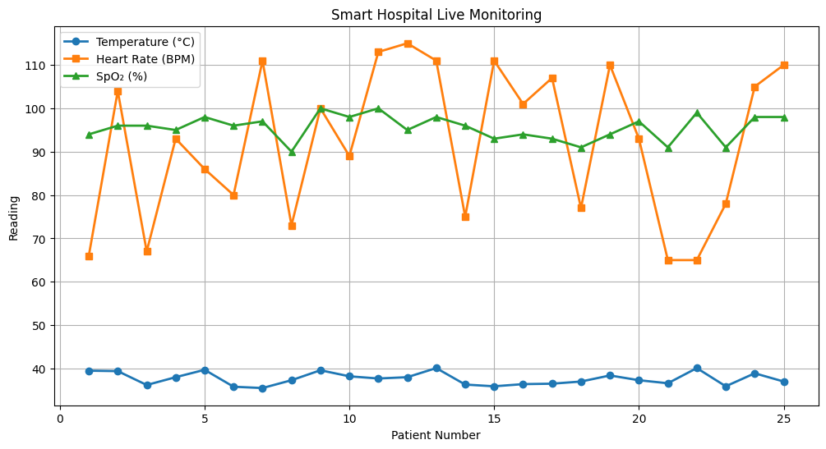

======================================================================
MONITORING COMPLETED SUCCESSFULLY
======================================================================
 | Patient | Temperature (°C) | Heart Rate (BPM) | SpO₂ (%) | Status
0 | P01 | 39.5 | 66 | 94 | EMERGENCY
1 | P02 | 39.4 | 104 | 96 | EMERGENCY
2 | P03 | 36.2 | 67 | 96 | NORMAL
3 | P04 | 38.0 | 93 | 95 | EMERGENCY
4 | P05 | 39.7 | 86 | 98 | EMERGENCY
5 | P06 | 35.8 | 80 | 96 | NORMAL
6 | P07 | 35.5 | 111 | 97 | EMERGENCY
7 | P08 | 37.3 | 73 | 90 | EMERGENCY
8 | P09 | 39.6 | 100 | 100 | EMERGENCY
9 | P10 | 38.2 | 89 | 98 | EMERGENCY
10 | P11 | 37.7 | 113 | 100 | EMERGENCY
11 | P12 | 38.0 | 115 | 95 | EMERGENCY
12 | P13 | 40.1 | 111 | 98 | EMERGENCY
13 | P14 | 36.3 | 75 | 96 | NORMAL
14 | P15 | 35.9 | 111 | 93 | EMERGENCY
15 | P16 | 36.4 | 101 | 94 | EMERGENCY
16 | P17 | 36.5 | 107 | 93 | EMERGENCY
17 | P18 | 37.0 | 77 | 91 | EMERGENCY
18 | P19 | 38.4 | 110 | 94 | EMERGENCY
19 | P20 | 37.3 | 93 | 97 | NORMAL
20 | P21 | 36.6 | 65 | 91 | EMERGENCY
21 | P22 | 40.1 | 65 | 99 | EMERGENCY
22 | P23 | 35.9 | 78 | 91 | EMERGENCY
23 | P24 | 38.9 | 105 | 98 | EMERGENCY
24 | P25 | 37.0 | 110 | 98 | EMERGENCY
CSV file saved as Smart_Hospital_Report.csv

